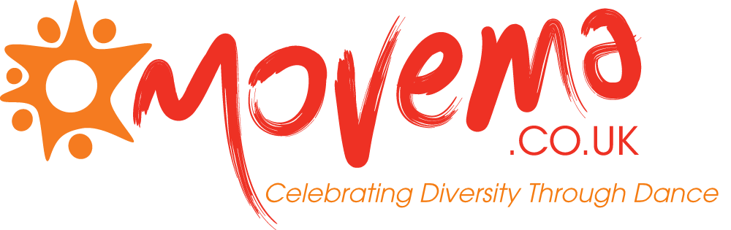
Email: admin@movema.co.uk | Phone: 0754865869 | Address: Movema, Toxteth TV, 37-45 Windsor Street, Liverpool L8 1XE | Website: www.movema.co.uk | Social Media: @movema
APPLICATION FORM
Please return your completed form by email to admin@movema.co.uk
PRIVATE AND CONFIDENTIAL
Deadline: 24 Sep 2021
SECTION 1- APPLICANT DETAILS AND MEDICAL & CONTACT INFORMATION
COURSE APPLIED FOR: Making Moves

FIRST NAME: |  | SURNAME:
ADDRESS:

POSTCODE: | E-MAIL ADDRESS:
PHONE NUMBER:
HOW DID YOU FIND OUT ABOUT THIS PROGRAMME?
☐Social Media/Newsletter ☐Movema Website ☐Whatsapp group ☐From a friend
☐From a support agency (please name): ……………………………. ☐Other (please state): …………………………….
DO YOU IDENTIFY AS ANY OF THE FOLLOWING?
☐Single-parent household ☐Person seeking asylum or refugee ☐Low-income household
☐Adult with mental health illness ☐None ☐Prefer not to say
WOULD YOU LIKE TO BE ADDED TO OUR MAILING LIST? ☐YES ☐NO
DO YOU HAVE ANY MEDICAL CONDITIONS THAT YOU MAY NEED SUPPORT WITH WHEN TAKING PART IN MOVEMA ACTIVITIES?

IN CASE OF EMERGENCY, WHO WOULD YOU LIKE US TO CONTACT?
NAME:
NUMBER:
RELATIONSHIP TO YOU:
SECTION 2- ACCEPTANCE CRITERIA (if invited to interview you will be asked to provide evidence of the following – see *asterisk for accepted evidence)
ARE YOU AGED OVER 19 YEARS OLD? |  |  | ☐YES | ☐NO | *ACCEPTED EVIDENCE: FULL PASSPORT (EU MEMBER OR NON EU STATE), BIRTH CERTIFICATE, DRIVERS LICENSE
DATE OF BRITH (DD/MM/YYYY):

ARE YOU ELIGIBLE TO WORK IN THE UK? |  |  | ☐YES | ☐NO | *ACCEPTED EVIDENCE: FULL PASSPORT (EU MEMBER), BIRTH CERTIFICATE, ID CARDS, FULL PASSPORT FROM NON-EU STATE (INDEFINITE LEAVE TO REMAIN)
ARE YOU UNEMPLOYED AND NOT IN EDUCATION? |  |  | ☐YES | ☐NO | *ACCEPTED EVIDENCE: DWP/JOB CENTRE BENEFITS DECISION LETTER, WRITTEN REFERRAL FROM DWP/JOB CENTRE, WRITTEN CONFIRMATION FROM A THIRD PARTY OF ASSISATANCE TO THE UNEMPLOYED INDIVIDUAL (i.e. charity, support agency, voluntary organisation)
NATIONAL INSURANCE NUMBER:

ARE YOU A RESIDENT WITHIN THE LIVERPOOL CITY REGION? |  |  | ☐YES | ☐NO | *ACCEPTED EVIDENCE: FULL PASSPORT, CORRESPONDENCE TO HOME ADDRESS WITHIN 3 MONTHS (i.e. billing letter), DRIVING LICENSE
SECTION 3- WHY ARE YOU THE IDEAL CANDIDATE FOR THIS COURSE?
WHY DO YOU WANT TO TAKE PART IN MAKING MOVES? (MAX 250 WORDS) (e.g. what interests you about the programme and why do you think you’re the right candidate)

HOW IS DANCE IMPORTANT TO YOUR LIFE? (MAX 250 WORDS)

HOW DO YOU WANT DANCE TO BE PART OF YOUR LIFE IN THE FUTURE? (MAX 250 WORDS)

WHAT ARE YOUR QUALIFICATIONS OR EXPERIENCE IN DANCE? (MAX 250 WORDS) (please state any formal or informal qualifications both from the UK and/or internationally)

SECTION 4- DECLARATION
OTHER INFORMATION
In line with our Confidentiality Policy all information provided below will be handled securely and confidentially, having due regard to appropriate legislation including data protection. Any information will not be used to treat individuals unfairly or to discriminate but will be considered along with other relevant information from the course recruitment process.
DECLARATION (Please read carefully before signing this application)
I declare that the information contained in this application is correct to my knowledge and belief. I understand that my application may be rejected or that I may be dismissed for withholding relevant details or giving false information. I consent to Movema checking any information that I am unable to verify personally. I consent to provide proof of evidence as needed to be accepted onto the course.
I acknowledge and accept that my data will be stored securely in manual / automated records. I acknowledge that they will be processed solely by Movema and funding partners in connection with the recruitment and monitoring of my personal records if I am the successful candidate on this course.

Signed: Date:

Print Name:

Please note that if you are completing and sending this form electronically you will be required to sign it if appointed.
Please return to by email: admin@movema.co.uk
Deadline date for applications: 24 Sep 2021

